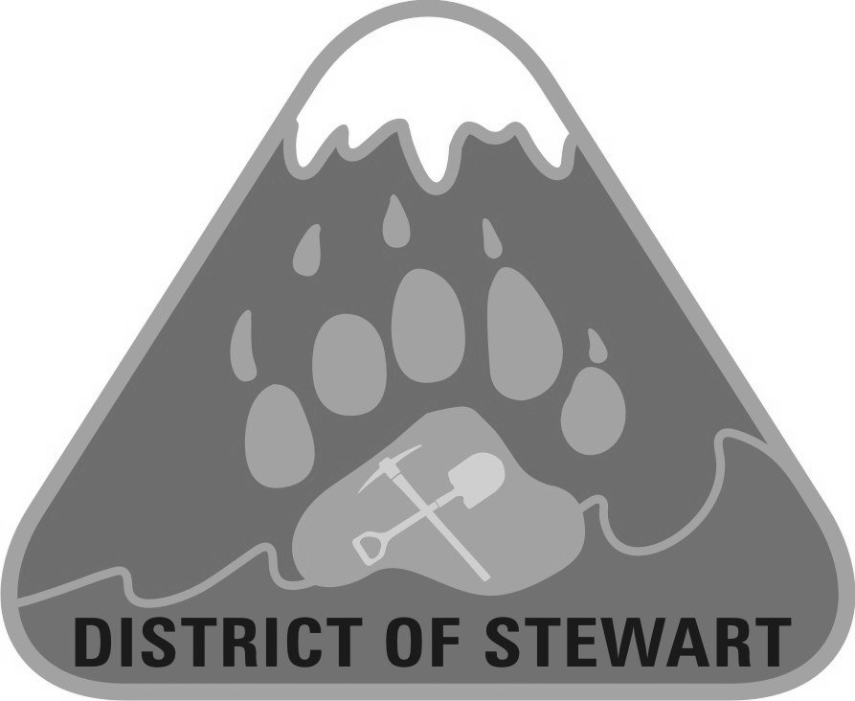
DELEGATION REQUEST FORM

Please submit your completed application forms by 1:00 pm, on the Tuesday prior to the Council Meeting you wish to attend: email info@districtofstewart.com, or Fax (250) 636-2417 or in person to 705 Brightwell Street.

Council Meeting Date Requested: |  |  |  | Date of Request:
Applicant Name: |  |  |  | Title/Organization:  (if applicable)
Subject of Presentation:
Summarize the Matter you Wish to Speak to as a Delegate-Include Questions you Wish to Have Answered, if Applicable:
List Any Additional Individuals Making a Presentation to Council: | Name:  2.  3. |  |  |  |  | Title:
Purpose of Presentation (mark with “x”)
Purpose of Presentation (mark with “x”) |  |  | Information only |  |  |  | Requesting a letter of support
Purpose of Presentation (mark with “x”) |  |  | Requesting Funding: |  |  |  | Other (provide details below)
Purpose of Presentation (mark with “x”) |  |  | (Amount): $
Will you be providing supporting documentation?
Will you be providing supporting documentation? |  |  | Yes |  |  |  | No
Will you be providing supporting documentation? |  | If Yes:
Will you be providing supporting documentation? |  |  | Handouts at meeting (bring at least 11 copies)
Will you be providing supporting documentation? |  |  | Publication in Agenda (1 original due by 1:00pm the Tuesday prior  to the Council Meeting )
Technical Requirements
Technical Requirements |  |  | Flip chart |  |  |  |  |  | Easels
Technical Requirements |  |  | Multimedia projector |  |  |  |  |  | Laptop
Technical Requirements |  |  | Other (provide details):

- Presentations are limited to under 10 minutes. If you require more than 10 minutes delivering your presentation, advance notice to the District staff should be provided to facilitate meeting schedule and permission of Council will need to be sought;
- PowerPoint presentations maximum of six slides;
- Presentations must not be for the purposes of personal, professional or pecuniary benefit;
- Visualizations must be factual;
- Delegations regarding any aspect of an Official Community Plan or Zoning application are prohibited between the conclusion of the Public Hearing and adoption of the Bylaw due to legal restrictions. Personal information on this form is collected under the authority of the District of Stewart Procedure Bylaw to be used for the purpose of conducting the meetings of the Board. Questions may be directed to the, FOI Coordinator at (250) 636-2251.

PLEASE NOTE: The Information you provide in this section will not appear on the District of Stewart Agenda

Applicant Contact Information:
Address:
Contact
Phone Number:
Alternate Phone #
Email:

For Office Use:

Approval Status of Delegation:

Is this Delegation approved for the requested Council Meeting?

Yes |  | No |  | Mayor Signature |  | Print Name |  | Date
Yes |  | No |  | Corporate Officer Signature |  | Print Name |  | Date

If not approved, is Delegation deferred to a future Council Meeting:

Yes |  | No |  | Meeting Date (if applicable)

Comments:

